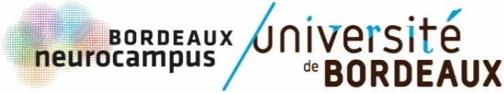

CALL FOR PROPOSAL

Bordeaux Neurocampus Travel Grant 2023

OBJECTIVES

Bordeaux Neurocampus launches a call to support its PhD students / post-doc to participate in international meetings (NeuroFrance, FENS, SfN, ...).
10 grants of 500 € will be offered to the winners.

ELIGIBILITY CRITERIA

- PhD students in 2nd year or more / post-doctorant
- Member of one of Bordeaux Neurocampus institutes
- Only one application per mentor
- Not being a laureate of another travel grant to assist to this meeting
- To be registered to the meeting and to present a poster as 1st author
- The allocated funds must be spent within 2023
- Eligible for congresses taking place in 2023 (outside Bordeaux)

EVALUATION CRITERIA

- Abstract submitted to the meeting
- CV
- Motivation letter

SUBMISSION

Send your candidature by e-mail to julia.goncalves@u-bordeaux.fr.
Deadline: 15/09/2023.

Your application will be evaluated by the Bordeaux Neurocampus Department Council.

CALL FOR PROPOSAL

Bordeaux Neurocampus Travel Grant 2023

NAME:

PhD / POST-DOC PROJECT TITLE:

PhD YEAR:

INSTITUTE:

TEAM LEADER:

PhD / POST-DOC MENTOR:

☐ I hereby certify that I am not a laureate of another travel grant to assist to this meeting.

ABSTRACT SUBMITTED TO THE MEETING (0,5 page max)

CURRICULUM VITAE, INCLUDING FELLOWSHIP OBTAINED FOR THE FIRST 3 YEARS, PUBLICATION LIST, PUBLISHED, SUBMITTED, AND IN PROGRESS (2 pages max)

MOTIVATION LETTER (1 page max)

