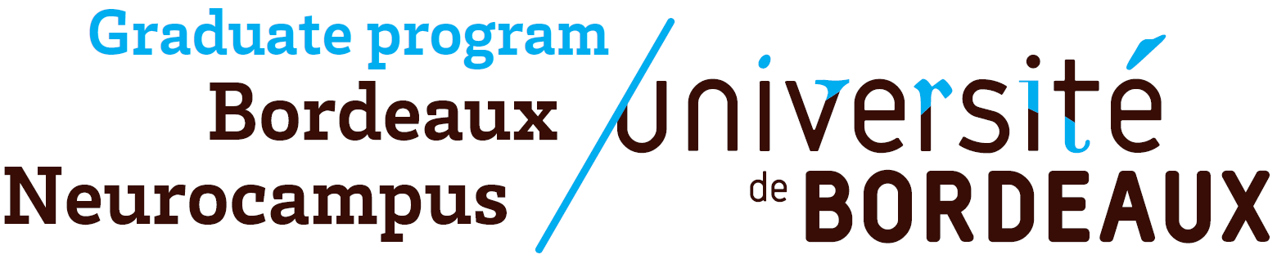
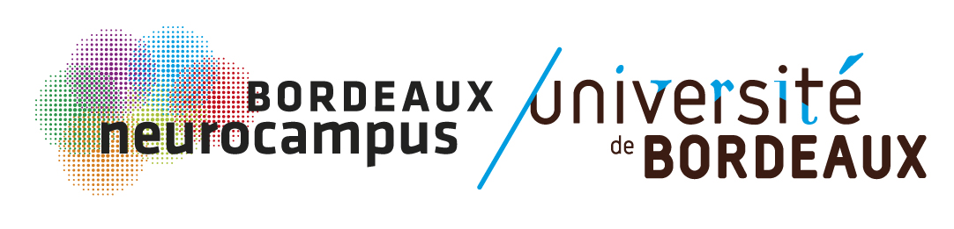

Call for proposal

Bordeaux Neurocampus Doctoral Research Awards 2023

OBJECTIVES

The Bordeaux Neurocampus department and the Bordeaux Neurocampus Graduate Program launch the 3rd call for proposal in order to reward outstanding doctoral research in Neuroscience.

Selected Ph.D. students will be invited to present their effective Ph.D. work to the whole community of Bordeaux Neurocampus on June 20th 2023.
Members of the Department Council and Graduate Program executive board will pre-select the best applications in April 2023. The winners of the 2023 Bordeaux Neurocampus Doctoral Research Awards will be then awarded 4 cash prizes of €500.

ELIGIBILITY CRITERIA

- Participants should be PhD students enrolled in one of the Doctoral Schools of the University of Bordeaux and working in one of the Bordeaux Neurocampus department laboratory
- Only one application per person for the duration of their thesis

SELECTION CRITERIA FOR THE PRE-SELECTION

- Significance and clarity of the research proposal
- Appropriateness of the methodology

- Quality of the data
- Positioning / Impact of the work in the scientific field

EVALUATION CRITERIA FOR THE AWARD

- Objectives and scientific hypotheses
- Impact and significance of the results
- Pedagogy and quality of the visual support

SUBMISSION

Send your candidature by e-mail to julia.goncalves@u-bordeaux.fr.
Deadline: Thursday March 30th 2023.

Call for proposal

Bordeaux Neurocampus Doctoral Research Awards 2023

PROJECT TITLE:

NAME:

YEAR OF PHD:

INSTITUTE / TEAM LEADER:

ABSTRACT (250 words max)

PROJECT DESCRIPTION & SUMMARY OF THE WORK ACCOMPLISHED (2 page max + 1 figure max)

(Impact of the work / Situation of the work in the scientific environment)

BIBLIOGRAPHY (No selection on your published articles, 1 page max)

CURRICULUM VITAE (1 page max)

