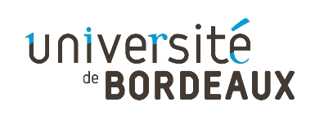
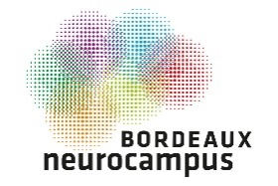
Call for proposal

Bordeaux Neurocampus Seed Projects

OBJECTIVES

Bordeaux Neurocampus launches a call for proposal in order to support preparation phase before submission to national or international grant. Seed money funding should be used to obtain preliminary results to reinforce an intra-Bordeaux Neurocampus collaboration preparing a project submission to ANR and other major grants.

ELIGIBILITY CRITERIA

- Participants should respect a) or b) criteria:
  - The project should involve at least 2 members. It is recommended but not mandatory to involve partners from different institutes of Bordeaux Neurocampus. Partners from other departments can be added but cannot be funded by Bordeaux Neurocampus. The collaboration should be new: the partners have not published together in the last 3 years.
  - The candidate is a young tenure researcher, as defined by ANR JCJC (PhD thesis defended less than 10 years ago, after 01/01/2011).
- Only one application per person.
- The allocated funds should be spent within 2021.
- The maximum amount of the project is 20 k€.

EVALUATION CRITERIA

- Objectives and scientific hypotheses
- Significance: Does the project address an important problem or a critical barrier to progress in the field?
- Complementarity: Do the investigators have complementarity and integrated expertise appropriate for the project? If the candidate is a young tenure researcher, does he/she has complementarity with his/her team?
- Innovation and originality: Are the concepts or methodologies novel or original?
- Feasibility and competitiveness: Is the work program feasible in due time and budget, and the potential results decisive?

SUBMISSION

Send your candidature by e-mail to julia.goncalves@u-bordeaux.fr.
Deadline: February 10th, 2021 at 2.00 pm.

Call for proposal

Bordeaux Neurocampus Seed Projects

ACRONYM:

PROJECT TITLE:

COORDINATOR (NAME, LAB):

PARTNERS (NAME, LAB):

☐ I hereby certify that I am submitting a new project not yet funded

SUMMARY
(250 words max)

DESCRIPTION OF THE CONTEXT, POSITIONING AND GENERAL OBJECTIVE

(1 page max)

PROJECT STRUCTURE, MAIN OBJECTIVES AND METHODOLOGY

(1 page max)

EXPECTED RESULTS, PERSPECTIVES AND IMPACT

(0,5 page max)

DESCRIPTION OF EACH PARTNER'S CONTRIBUTION
(0,5 page max per partner + 3 relevant publications per partner)

BUDGET
(Running cost, equipment or human resources, the allocated funds should be spent in 2021. 1 page max)

REFERENCES

