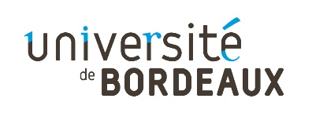
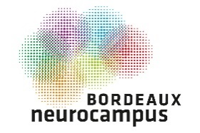
Call for proposal

Bordeaux Neurocampus Doctoral Research Awards 2021

OBJECTIVES

The Bordeaux Neurocampus department of the University of Bordeaux launches a new call for proposal in order to reward outstanding doctoral research in Neuroscience.

12 Ph.D. students will be invited to present their effective Ph.D. work to the whole community of Bordeaux Neurocampus during two half-days in spring 2021.
Members of the Department Council will pre-select the best applications in February 2021. The 2021 BORDEAUX NEUROCAMPUS DOCTORAL RESEARCH AWARD WINNERS will be then attributed during the “Bordeaux Neurocampus 2021 day” and 3 cash prizes of €500 will be awarded.

ELIGIBILITY CRITERIA

- Participants should be PhD students enrolled in one of the ED of the University of Bordeaux and working in one of the Bordeaux Neurocampus department laboratory
- Only one application per person

SELECTION CRITERIA FOR THE PRE-SELECTION

- Significance and clarity of the research proposal
- Appropriateness of the methodology

- Quality of the data
- Positioning / Impact of the work in the scientific field

EVALUATION CRITERIA FOR THE AWARD

  - Objectives and scientific hypotheses
  - Impact and significance of the results
  - Pedagogy and quality of the visual support

SUBMISSION

Send your candidature by e-mail to julia.goncalves@u-bordeaux.fr.
Deadline: January 29th 2021 at 2.00 pm

Call for proposal

Bordeaux Neurocampus Doctoral Research Awards 2021

PROJECT TITLE:

NAME:

YEAR OF PHD:

LABORATORY / TEAM:

ABSTRACT
(250 words max)

PROJECT DESCRIPTION & SUMMARY OF THE WORK ACCOMPLISHED

(Impact of the work / Situation of the work in the scientific environment) (2 page max + 1 figure max)

BIBLIOGRAPHY

(No selection on your published articles)

CURRICULUM VITAE

(1 page max)

