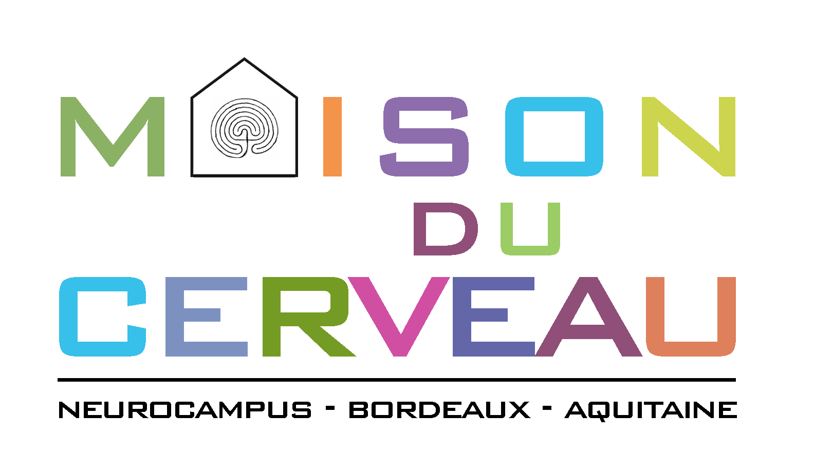

Student Name :
Laboratory :
Supervisor Name :

Project Title :
Main topic :

Project description (500words maximum, including figure legend, 1figure max)

References (5 max)

Student CV (University cursus…), 1 page max

